**Product Sales Chart**

Latest release includes an updated option for the Product Palette for use on the Product Properties, Buying Details and the Product Item Finder (consolidated version). New option is a graph for showing product sales in a chart instead of only list form.

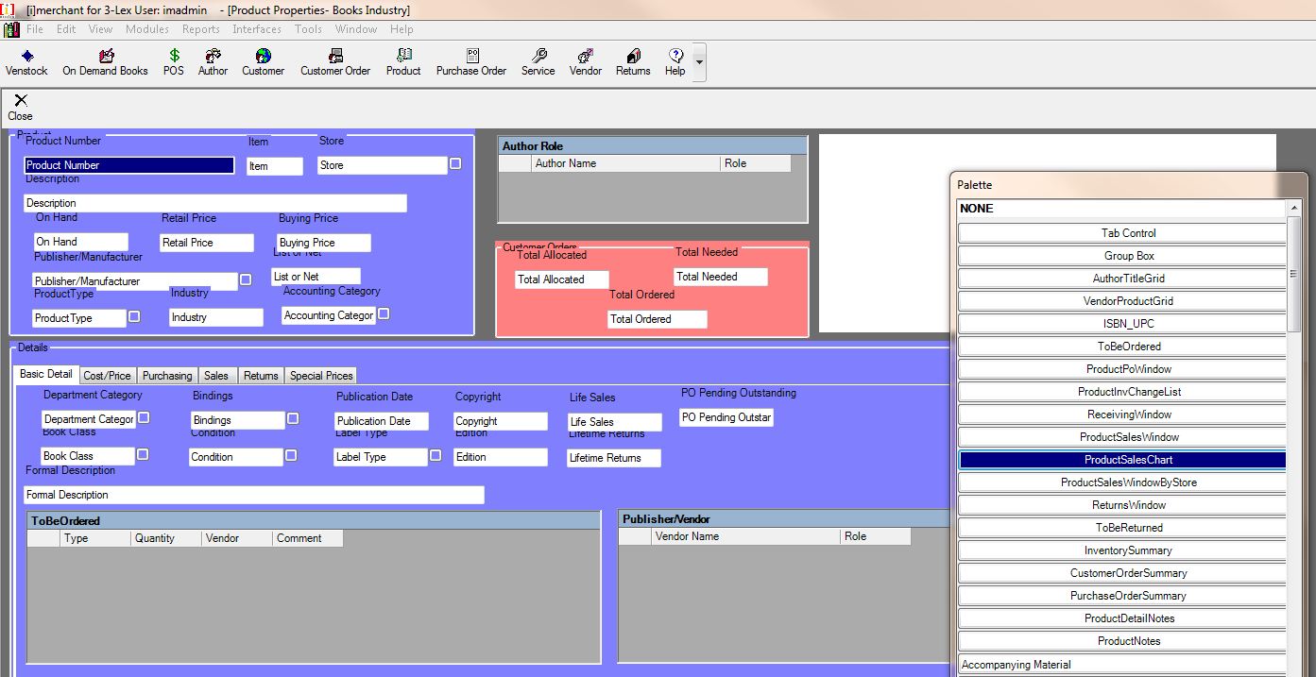

Drag and drop the new option onto your form to enable the new chart view, feature is called “Product Sales Chart”. Once you add the chart onto your form and save the design, you can come back later and change the date range from Daily, Weekly, Monthly or Yearly sales data.

**Buying Details**

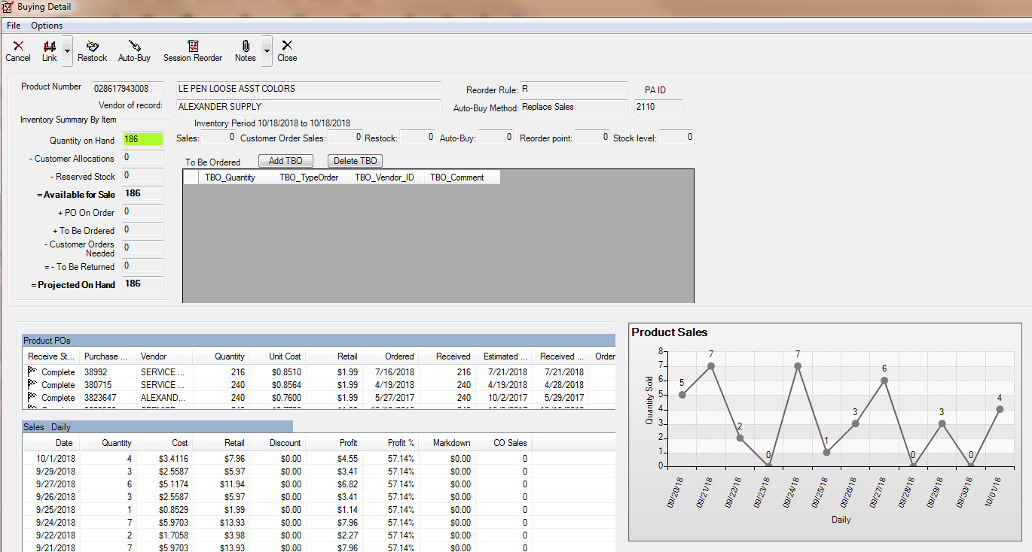

**Product Properties**

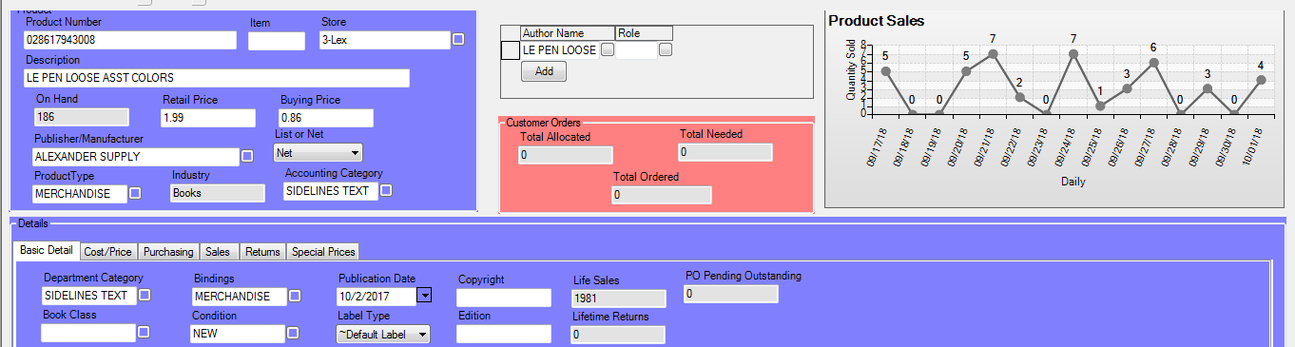

**Product Item Finder (Consolidated)**

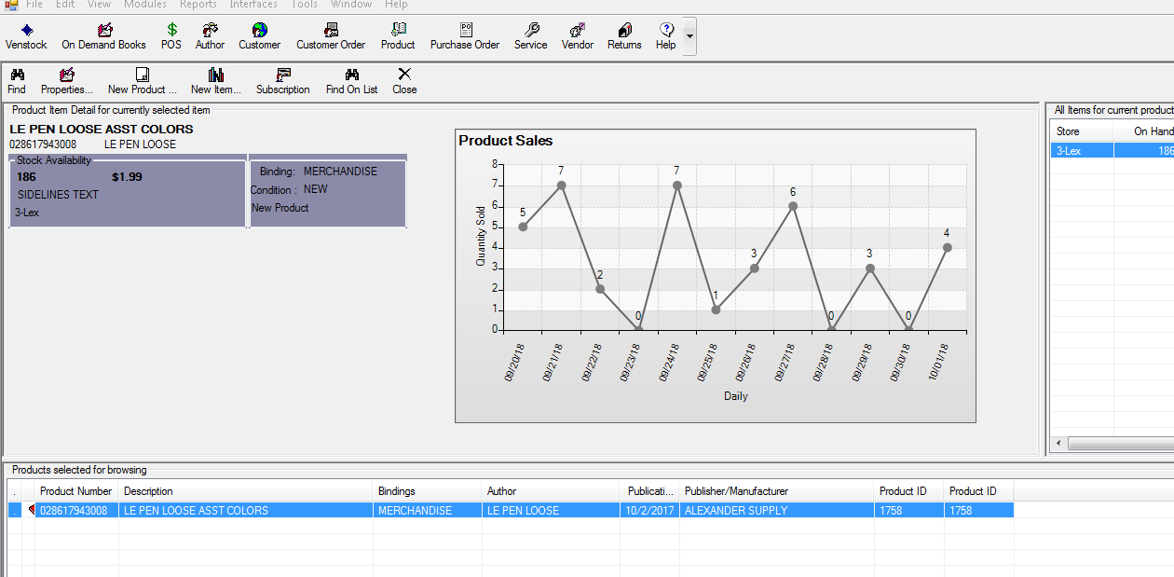

You can also change the data to show quantity sold or net sales totals on each graph, one by one. Right click on a graph to see the options to change the data type and date range.

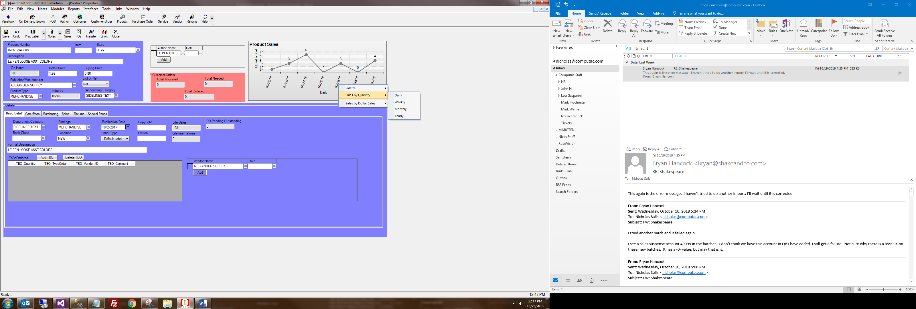

Sticky settings will save the particular chart you saved for you automatically.